

#Iteration WEBSITE

- Slider banners updated in both the websites.

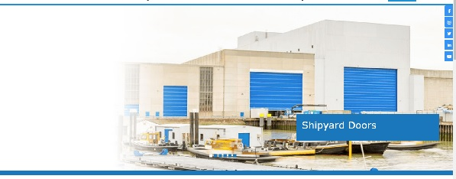

- Client logos size reduced in nihvaautomation website which were looking bigger.



Task Marketing Reports WEBSITE

#Iteration WEBSITE

- Home page updated for nihva.com.

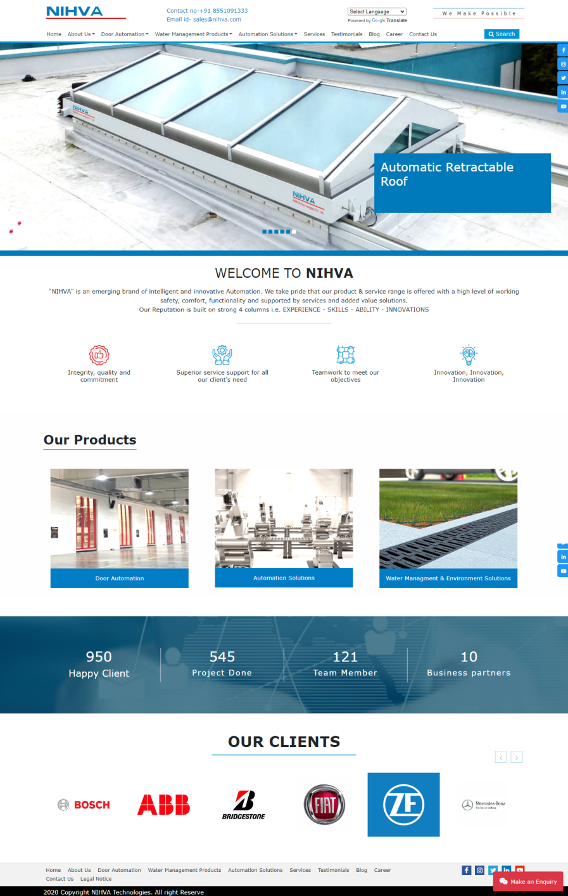

Task Marketing Reports WEBSITE

#Iteration WEBSITE

- Font size and font style fixed for all product pages.

- About us page updated in nihva automation website. International partners section added.

- Nihva automation header height reduced.

- Website images which were not looking good updated in both the websites.

- Content updated in both the websites.

- Sticky header changed to default header in nihva website.

- Products are aligned as per the sitemap in both the websites.

- Removed unnecessary hyperlinks.

- Error fixed for https://nihva.com/water-management-products when page is scrolling.

Task Marketing Reports WEBSITE

#Iteration WEBSITE

Below blogs were posted in the website

- https://nihva.com/high-performance-doors-for-food-industry

- https://nihva.com/solutions-for-warehouse-and-docking-challenges

- https://nihva.com/sustainable-buildings-with-automatically-green-certified-doors-and-retractable-roofs

- https://nihva.com/need-and-applications-of-material-handling-equipment-in-diffrent-industries

Task Marketing Reports WEBSITE

